Nectria jOc."a Samuels, sp. nov.
Etyruology: 'joca' from the latin word meaning 'jokc' or 'jcst" in referencc to the authors' surprise at finding a specîes other than.11/ectria vîlior growing on a tropîcai Hypôxylon.

1\ltt1riae \·iliori Starb. affinis scd ascosporae (9.)9.S-ll(-11.$) x 5.6-7(-7.4) µm; colonia in ag-aro salmoni<:olor; st<'ltus ana100rphîcus diffcrt . conidia 3.$-$.4(-6.5) x 1.2-2(..2.$) µm. Aeren1onium·simdis.

P<ritllecla pyriform. 210.-270 µm high. 180-240 'm 1,vide, wit h an acute apex. collapsi ng by lateral pinching . red . not chang.ing colour in 3% KOH. ycllow in làctic acid. s·mooth. dcn scly gregariou.s. superfie1ul, not obviously stromatic bu1 seatcd on a thin basal stroma . Cclls at surfaœ of pcrithecial w;ill fonning textura epidern1oide'1 with un e\'enly thic-kened walls. lumina of adjacent cells joined b)' fine porcs . Perithecial wall 15-20 µm wide.comprising 3 single reg.ion of intert.,vined hyphac 1ha1 in section have meandcring tumina and une\'enly thîckened walls lO 1.5 µm widc. PcrîthecîaJ apex rormed of hyph al elcmcnlS with rounded tips and arranged in a palisadc ;1hcse elen1enlS con1inuous wi1h the cells of the perilhecial wall below, g.radually bccomîng thinner lOward the ostiolar canal and mcrging with the periphyscs. Asci broadly cylindrical to narrowly e-lavatc, 58-68 x 6.5-8.5 µm. S sporcd, apex simpl e. Ascospores broadly ellipsoidal, (9.:>-)9.5-11(-11.8) x
5.6-7(-7.4) µ_n1. cqually 2·cclled. not cons11ric1ed at the septum. tuberculatc , yellow· brown. uniseriatc becomîng muhiseriat e.
Colonies grown 21 d at ca 2if C, diffuse d..aylight. Cti.10: barcly growing away from the original inoculum . aerial mycclium lacking.. slin1y. salmon·coloured. PDA: l cm diam. otheT\vise as on CfO. ConidiopJrores macronematous.mononematous. unbra 11ched and monophi alidîc. or irregularly branchcd. cach branch ternlînating in a si11gle phialide. 10 20 µm long. 2-3 µm at base. Phiafides 10-30 µm long. straight. smoo1h. 1ip l µm wide. apex with s:light peticlinal 1hickening and an unnared collarette. Co11itlit1 oblong to ellipsoïda l, 3.8-5.-l(-6.5) x 1.2-2(-2.5) tm. unicellular, lack ing a visible basal abscission scar. smooth, hyaline.
Typification: Bra:zil: Amazonas.Pico Ron<ion. km 211 on Perimetral Norte. ca 3h walk from FUNJ\.1 post toward summil. Ole.32'N. 02°48'\V. on Hypoxylou sp.. 25 f\1ar. 1984. Sa111utfs 109./, Ripofy & Guedes (holotype. INPA. isotypes BPI. NY).
Illustrations: Figs 11-12. 2.3. 2-l. 5-1-55. Su bslrata : Hypoxylon sp.
OiS1ribution: Brazil. kno"n only from 1hc type.
Notes:1Vec1ria joca differs from ,\-. l'ilior in having an Acrerno11iun1 anamorph thut is salmon in cullure. lVt•ctria 111ag1114sfru1a has slîghtly l:;ugcr asoosporcs and îs said (Booth. 1959) 10 occur onl}' on Dùurypeffa sp. on A/11141, Be1ulo and Fogus: i1s anam orph is Fusoriunt episrro1n1un. ,\"eetria ,ioca is also similar to ,\'.triqua. which has sahnon coloured colonies bul narrower asoospores and occurs on Dialr)·paceae (Eutypella). The cuhure of iV. joca is n o longer viable.
Two collections made in Ne.,., Zealand (Pl)D 1$6-l3. 3.&020) ire imilar to ,\1• jocll . Like
1V. joea. ascosporcs of the 'l'ew Ztaland co1Jcc1ion have tubcrculatc ast-o:-pôrcs. bul
\1nlike 1\'.j<>eà . 1here is a rcfr:.tclivc ring in the ascal apex. Pcrîthccia of thcsc collections rorm on. rcsctivdy. Hypoxlo11 sp. and a plcô'ioporaceous a"oomycctc. Colonies dcri\'cd from ascospores isolatcd fron1 POO 186"3 w(!rc slow·g.ro.,,ing. cream colourcd with dense hyphae on PDA. (onidiophor<s were not sccn in the: dried culture but conîdia \\ ere eUîpsoidal to ohlong. 5-- x l.5-.! tm. unicellular and colourlei;;s.

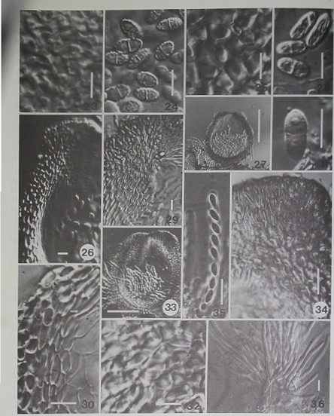
Figs 23, 24. /\'rc1rloJO<'"·l..'\ C'ells at surface of perithcâal Il. 24. Aporc•. GIS IO'H. fig 2>28. Nrctn'o lasuxl1plod1or 25. Cel! Al surface of peri1hcàal wall. 26. Perilhe<:1nl 1pcx nnd l111tral wall. 27. Median scc1ion 1hrough a mature perithecium. 2S. Di.sehargcd asrospores, Dllntorll·BR 1018. Figs: 29-31 Src1ri11 mo11u.u10110. 29. Scct:ion through pcritbccial apex 30. Scchon lhrouiti laten.I pcrithttîail waill JI A\C'O\pc>rc. Joop 18.Fîgs 32. 33. ;\'«triomrliopsicolo. Jl C'cllJ. ait sutfaoc of pcritbtQ1I -...,11 Jl \fcd&&n section through" mature pcn11'1«ium, R,uudrrt 2JS74 flP
»36. ,\'tttrl4 ff()tluptJp/ui< t111 Scellon through pentheci21apex. POO )079? 35. A1an. t"t>O 30793.36.. Cbnidiophorn. P003Cm"'9 Sale N:Fip 23-26. 28-l?. 34-36 10..m, F1 ' 21, JJ
so..,..
=

